Procedure for foreign specialist accommodation in UrFU’s dormitory
1. Issue a service note to the rector requesting the foreign specialist accommodation. The note should be signed by the director of the institute and the foreign specialist’ curator.
Sample in Russian is below
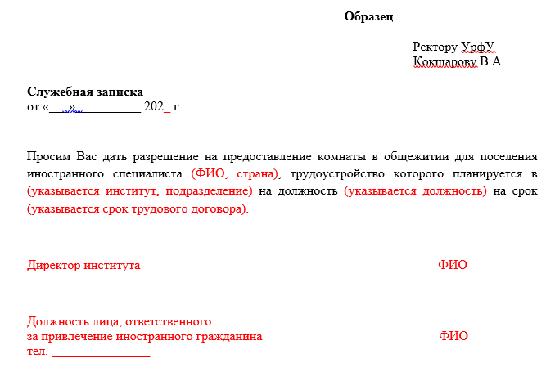

2. Contact Irina Sokolova (phone number 8(343)375-44-07) to request a list of documents required for a specialist accommodation in UrFU’s dormitory. The documents are to be checked at a meeting of the UrFU Housing Commission (St. Sofia Kovalevskaya, 5, office T-107 or T-103).

